Rhythm

Definition of rhythm

Rhythm is the timed sequence of sounds in music.

Time, beat, subdivision and feel

Most rhythm has a regular beat, which can group a finer division into larger units for practical counting, and which is also used for dancing. A cycle of beats is called the *time*. Within cycles of beats, there are usually stronger and weaker beats (sometimes also called *arsis* and *the*sis). The subdivision of each beat can be called the ”feel”.

Basic subdivisions of the beat

We will now look at the possible subdivisions per beat, in basic notation. In the examples below, you will therefore find a list of all possible subdivisions of both the quarter and the dotted quarter note, for binary and ternary time signatures.

Even though there are a great many possibilities already within these limits, I further limited the examples to a maximum *resolution* of 1/16 note, meaning that no smaller notes are involved, notated and listed. These rhythms do reach a certain degree of complexity, and even more complicated rhythms usually involve tuplets.

Still, the “catalogue” below lists commonly encoutered rhythmic building blocks, and studying -and being able to quickly recognize, clap or tap- these examples, greatly enhances one’s ability to connect and integrate one’s *hearing-reading-singing (clapping)-writing* as was explained in the introduction of this outline.

Binary subdivisions

The basic subdivisions of the *quarter note* for binary time signatures, up to a *resolution* of 1/16 notes, is found on the image below.

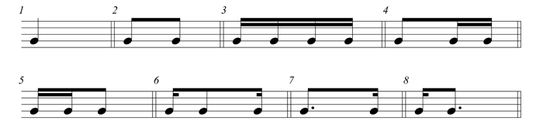

binary subdivisions of the quarter note

The building blocks exercises with these binary subdivisions are found here:

* [Rhythmic building blocks (binary – in 2/4)](http://www.oscarvandillen.com/wp-content/uploads/2014/02/Rhythmic-building-blocks-24.pdf)*(pdf)*

Ternary subdivisions

The basic subdivisions of the *dotted quarter note* for ternary time signatures, up to a *resolution* of 1/16 notes, is found on the image below.

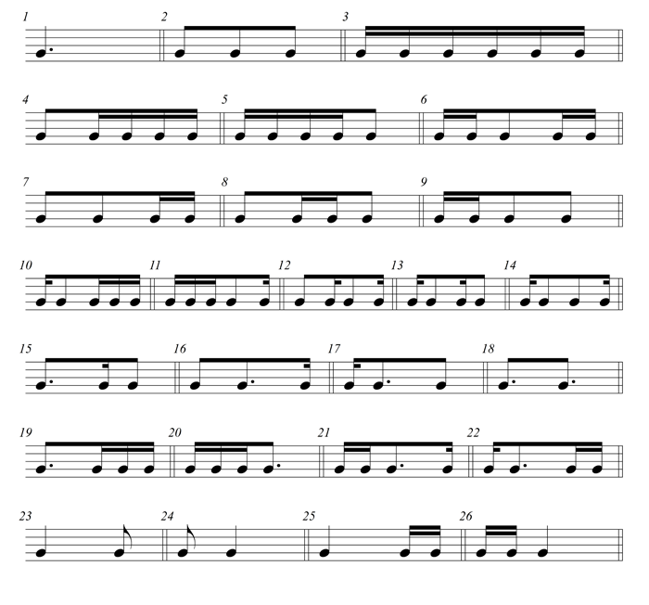

ternary subdivisions of the dotted quarter note

The building blocks exercises with these ternary subdivisions are found here:

* [Rhythmic building blocks (ternary – in 6/8)](http://www.oscarvandillen.com/wp-content/uploads/2014/02/Rhythmic-building-blocks-68.pdf)*(pdf)*

Polyrhythm

Polyrhythm is the simultaneous presence of more than one *beat* or *feel* in the same music.

The patterns below present the basic polyrhythmic patterns based on 2, 3 and 4 in mutual combinations. These should be practiced one after the other with two hands, while always keeping the beat in the same hand. The beat patterns here are notated with notestems downwards.

In the examples every first bar offers a tuplet notation, every second bar offers a notated analysis with the smallest common beat-particles regrouped by tying together, every third bar offers a practical notation which is best for performance (and especially much clearer than duplets and quadruplets).

3 against 2

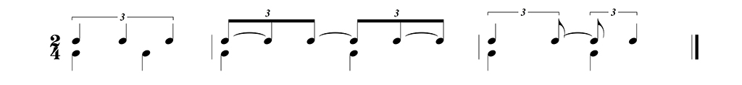

2 against 3

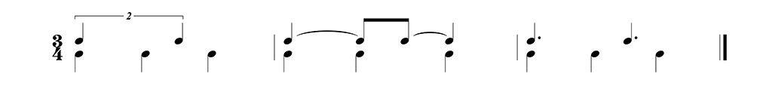

4 against 3

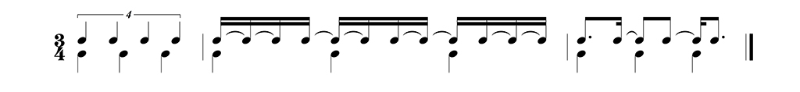

3 against 4

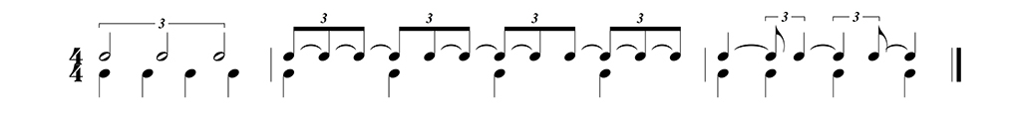

Some more advanced exercises with triplets are found here:

* [Rhythmic exercise concerning triplets](http://www.oscarvandillen.com/wp-content/uploads/2013/07/rhythmic-exercise-concerning-triplets.pdf) *(pdf)*