Advanced seventh chords

Definition of seventh chord

A ‘seventh chord is a special type of chord which consists of 4 different tones, in consecutive thirds.

The seventh chord thus consists of a minimum of six intervals: 3 thirds, 2 fifths and 1 seventh, or their respective inversions.

A seventh chord can be regarded as en expanded triad; each seventh chord itself consists of 2 triads.

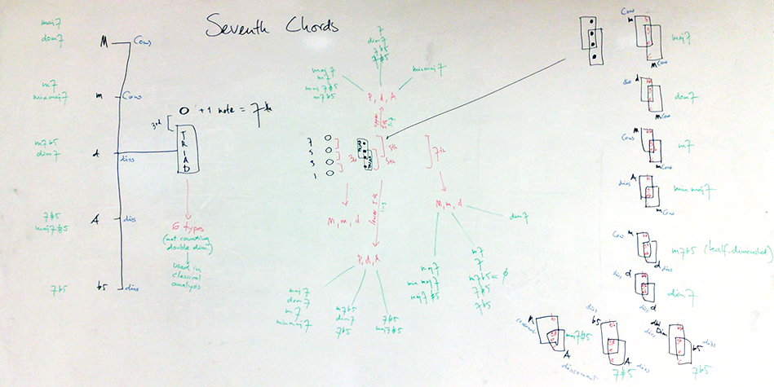

constructions and transformations of seventh chords

The relationships of all types of seventh chords with their constituent triads and intervals are shown in the whiteboard picture above.

Basic notation

The basic notation of a seventh chord, is by virtually taking tones 1, 3, 5 and 7 of a scale and writing them together, sounding as one.

The example below uses the basic tones only.

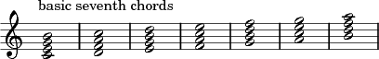

Types of seventh chords

Consisting of 3 thirds, 2 fifths and 1 seventh, the thirds can be major, minor or diminished, fifths can be perfect, diminished or augmented, the sevenths can be major, minor or diminished. There are no seventh chords which contain an augmented third, as the enharmonic equivalence of this interval, the perfect fourth, is such a strong consonant that its top note would acoustically assume the position of the root of the whole chord, thus leading to the perception of an extended triad. Thus the number of possible seventh chords is limited to just 11:

1. Major seventh chord: consisting of a major third, a minor third, a major third, two perfect fifths and a major seventh
2. Dominant seventh chord: consisting of a major third, a minor third, a minor third; one perfect fifth, one diminished fifth and a minor seventh
3. Minor seventh chord: consisting of a minor third, a major third, a minor third; two perfect fifths and a minor seventh (enharmonically equivalent to a Major triad with added 6 in third inversion)
4. Minor major seventh chord: consisting of a minor third, a major third, a major third; one perfect fifth, one augmented fifth and a major seventh
5. Half diminished chord: consisting of two minor thirds, a major third; one diminished fifth, a perfect fifth and a minor seventh (enharmonically equivalent to a Minor triad with added 6 in third inversion)
6. Diminished seventh chord: consisting of three minor thirds; two diminished fifth and a diminished seventh (enharmonically equivalent to itself in all inversions)
7. Augmented seventh chord: consisting of two major thirds, a minor third; an augmented fifth, a perfect fifth and a major seventh
8. Augmented dominant seventh chord: consisting of two major thirds, a diminished third; an augmented fifth, a diminished fifth and a minor seventh
9. Flat 5 dominant seventh chord: consisting of a major third, a diminished third, a major third; two diminished fifths and a minor seventh (enharmonically equivalent to itself in second inversion)
10. Double diminished minor seventh chord: consisting of a diminished third, a major third, a major third, a diminished fifth, an augmented fifth and a minor seventh (enharmonically equivalent to an Augmented dominant in third inversion)
11. Double diminished seventh chord: consisting of a diminished third, a major third, a minor third, a diminished fifth, a perfect fifth and a diminished seventh (enharmonically equivalent to a Dominant seventh in third inversion)

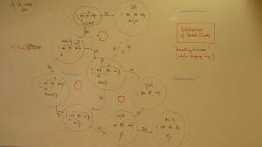The whiteboard image on the right shows the relative mutual proximity and similarity of the 9 basic seventh chords.

The arrows indicate how an alteration of one chord tone will change the chord into a neighbouring, different, but closely related, related seventh chord.

All seventh chords can occur on any tone, the notated example below shows all 11 theoretically possible seventh chords of c (alterations are needed to obtain the correct tones). In practice however, only 9 seventh chords have actual chord-symbols: the last two seventh chords have no chord-symbol of themselves. These two would rather be notated as third inversions, slash chords of d (D7#5/C and D7/C, as notated in small black notes), of which they are *enharmonic equivalents*:

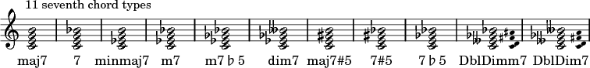

Symbols for seventh chords

For most music in which improvisation plays an important role, symbols are used for seventh chords.

There is no unity in the systems used for these symbols, as different symbols occur in different books.

Below is a table summarizing the most commonly used chord-symbols for seventh chords:

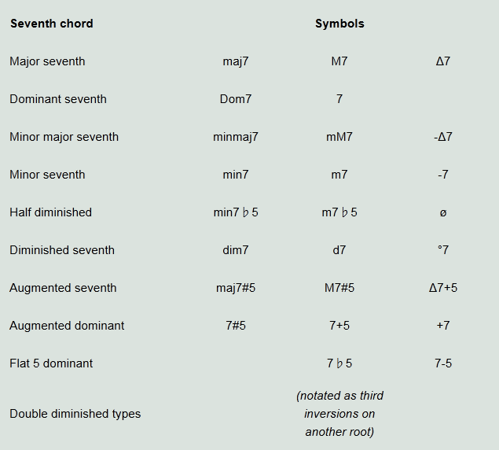

Inversions of seventh chords

A seventh chord is still considered to be the same seventh chord when the 4 tones it consists of are presented in another position than the basic 1-3-5-7 described so far. There are four basic positions for a seventh chord:

1. The 1 is the lowest tone, this is called root position, short: 7
2. The 3 is the lowest tone, this is called first inversion or six-five position, short: 6-5
3. The 5 is the lowest tone, this is called second inversion or four-three position, short: 4-3
4. The 7 is the lowest tone. this is called third inversion or second position, short: 2

The acoustic properties are different, yet these positions can be perceived as derived from one basic structure: the seventh chord.

The examples below are basic tone positions of seventh chords twice, both of c and on c:

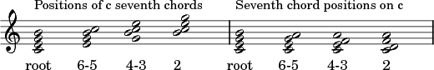  
The names of the inversions are derived from the intervallic structure: the inversions of the thirds become sixths (major, minor or augmented), the inversions of the fifths become fourths (perfect, augmented or diminished) and the inversions of the sevenths become seconds (major, minor or augmented).

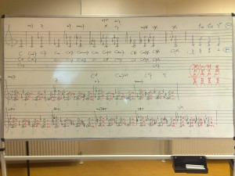The whiteboard image on the right shows a full table of the nine seventh chords that have chord symbols, in all inversions on c (and here not of c, as only the root positions are C chords!).

Use of seventh chords

Any scale or mode can be *harmonized* by forming seventh chords on all its steps. These seventh chords are then called degrees.

The harmony thus obtained is proper to that particular scale itself and can be modal or tonal, depending on its use.

Mutual sound relationships and possible transformations of seventh chords

As all seventh chords are closely related sounds, changing just one tone usually results in another seventh chord. These mutual sound relations and transformations are given in the image below:

